Azure Storage

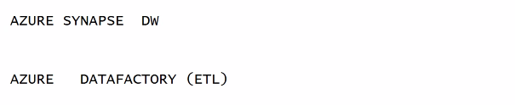

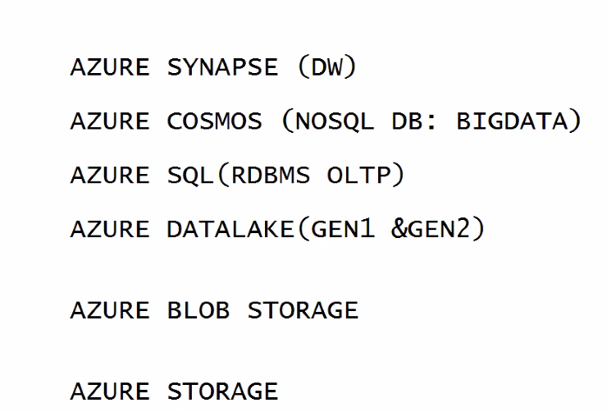

Cosmos DB

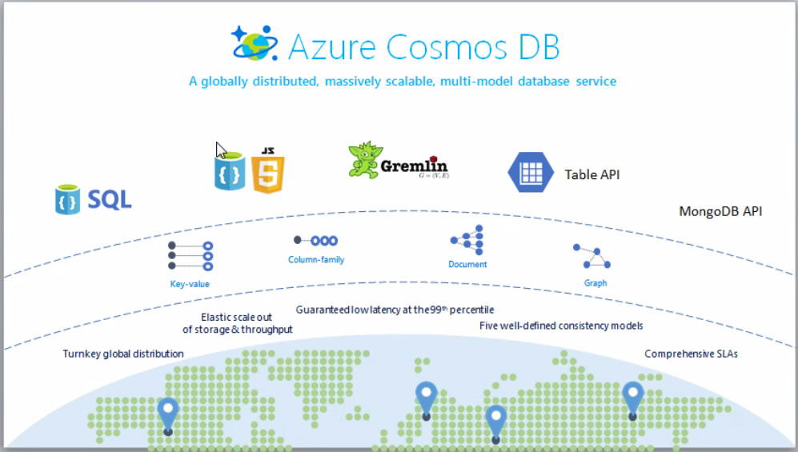

After deploying:

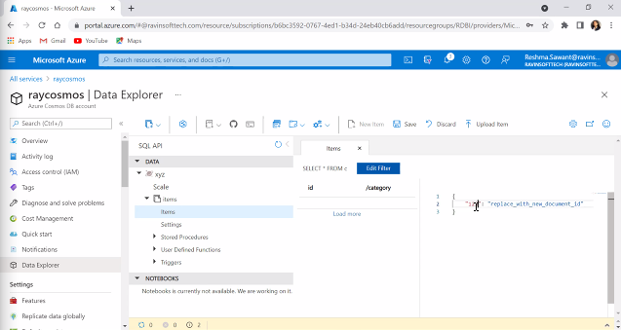

Wait for hands on material on Cosmos DB. Use Cosmos when importing data from Azure cloud.

Azure Datalake

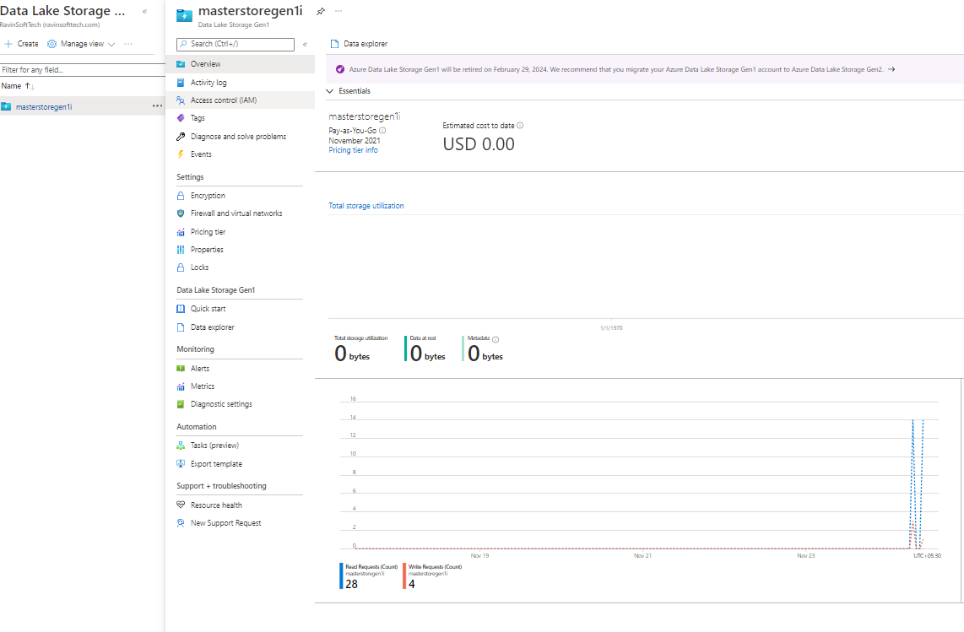

No Access

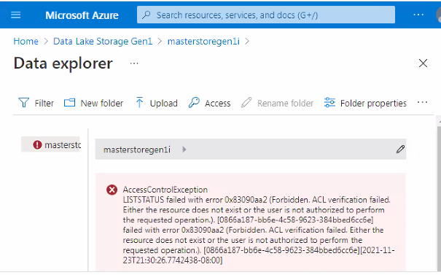

Follow instructions issued by the vendor for Datalake

Azure Data factory

To bring the data from any structured sources.

It can get from RDBMS or Dynamic source(like streaming with kafka)

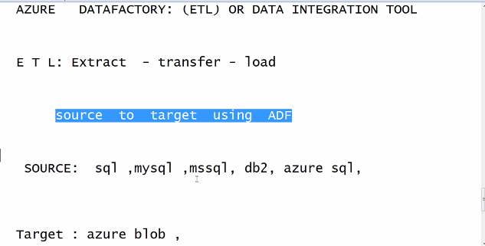

Use pipe data from multiple target

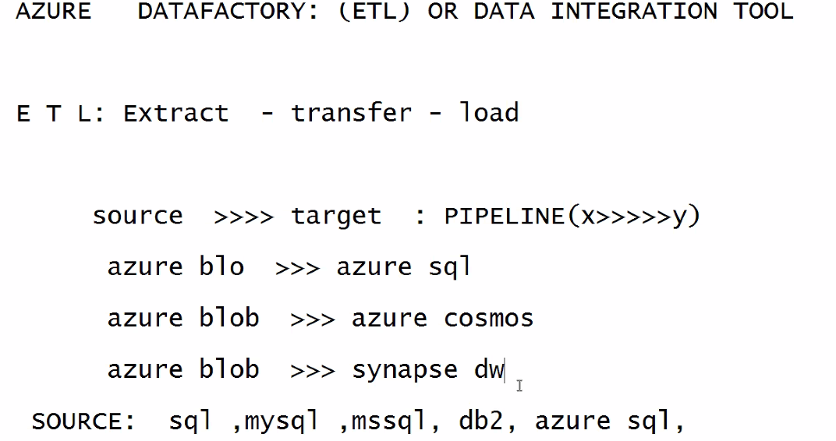

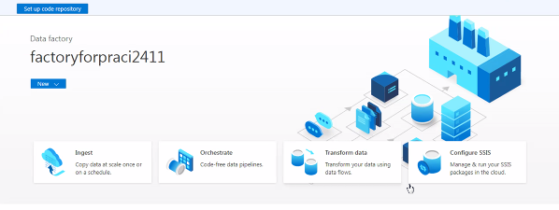

Follow this link for the whole pipeline process : https://docs.microsoft.com/en-us/azure/data-factory/tutorial-copy-data-portal

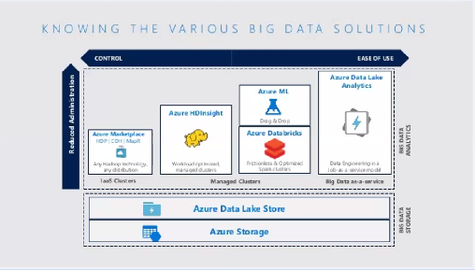

Spark analysis in Azure

Foww the below link for set up

https://docs.microsoft.com/en-us/azure/synapse-analytics/get-started-analyze-sql-on-demand

